1. Create mariadb db on ec2.

------ install mariadb in your ec2 instanaces

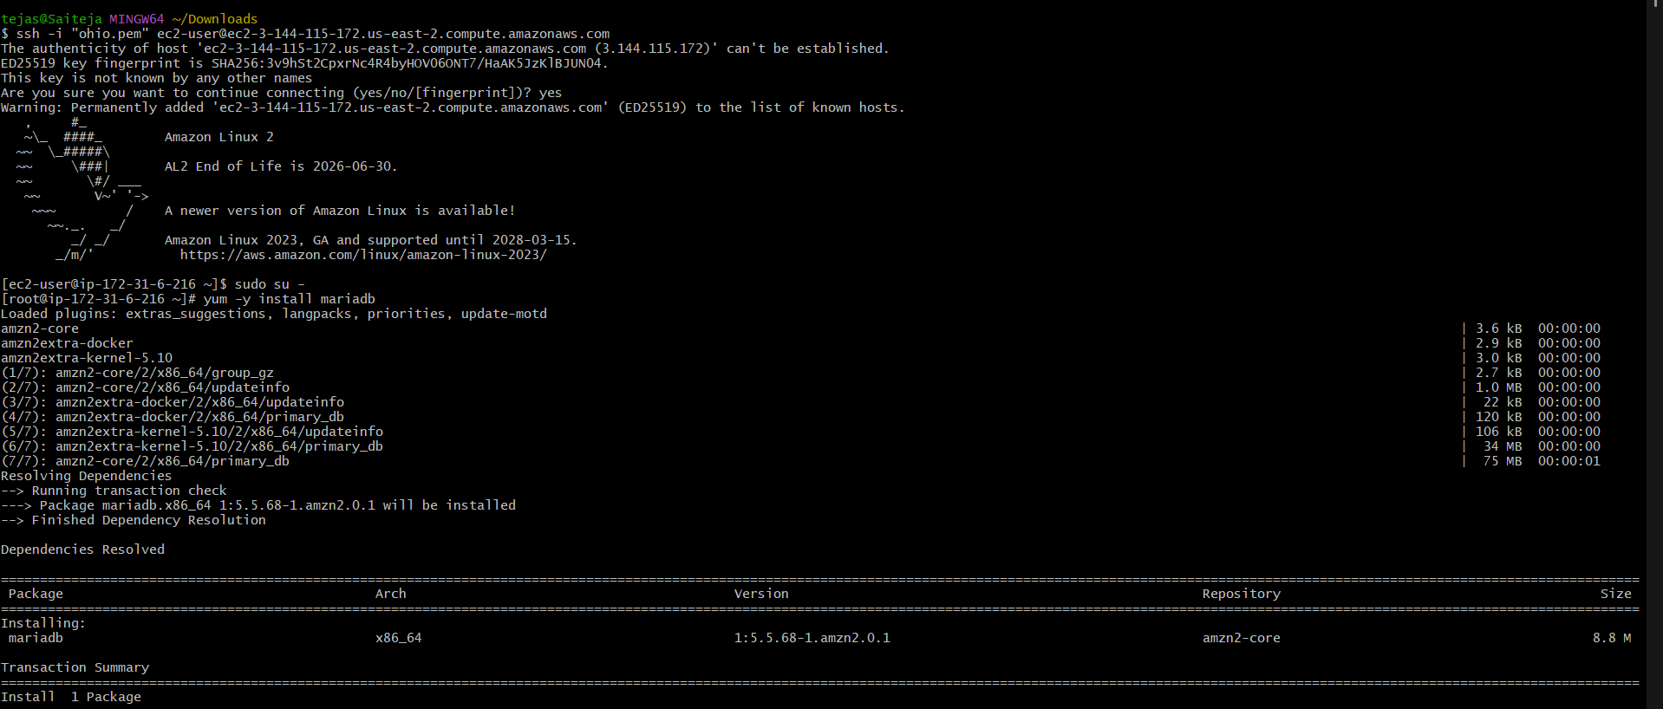

---- start mariadb using systemctl start mariadb

------ check status using systemctl status mariadb

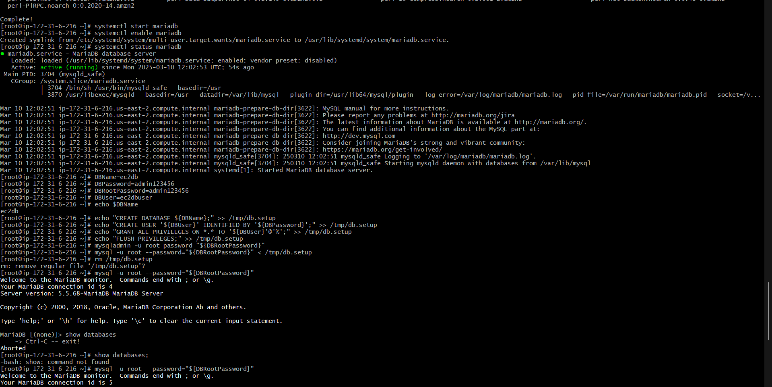

1. Insert some dummy data

---- Set Environmental Variables and Database Setup on EC2 Instance

--- creating user and setting password

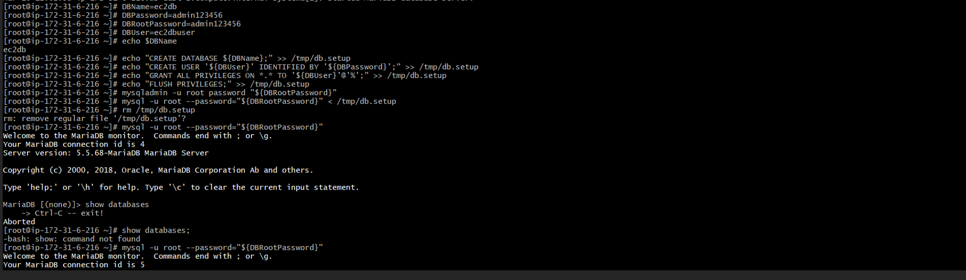

----- connect to the database and dump some data into data

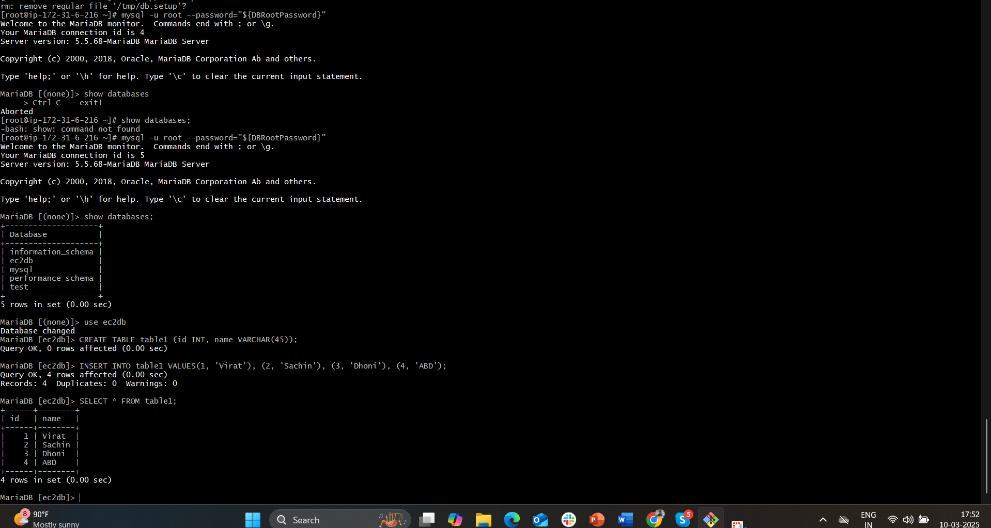

1. Take the backup of dummy data on ec2

----- switch to root user and take the backup of your database

----- using command mysqldump -u root databasename . filename

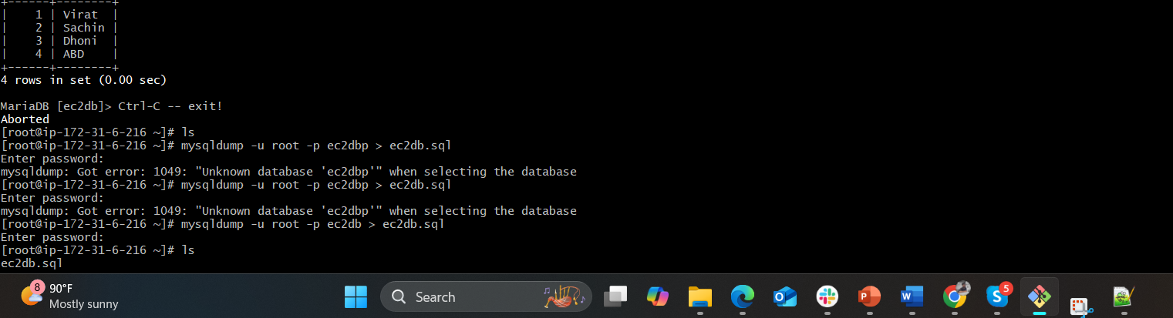

1. launch Mariadb RDS instance.

----- go to RDS and create database

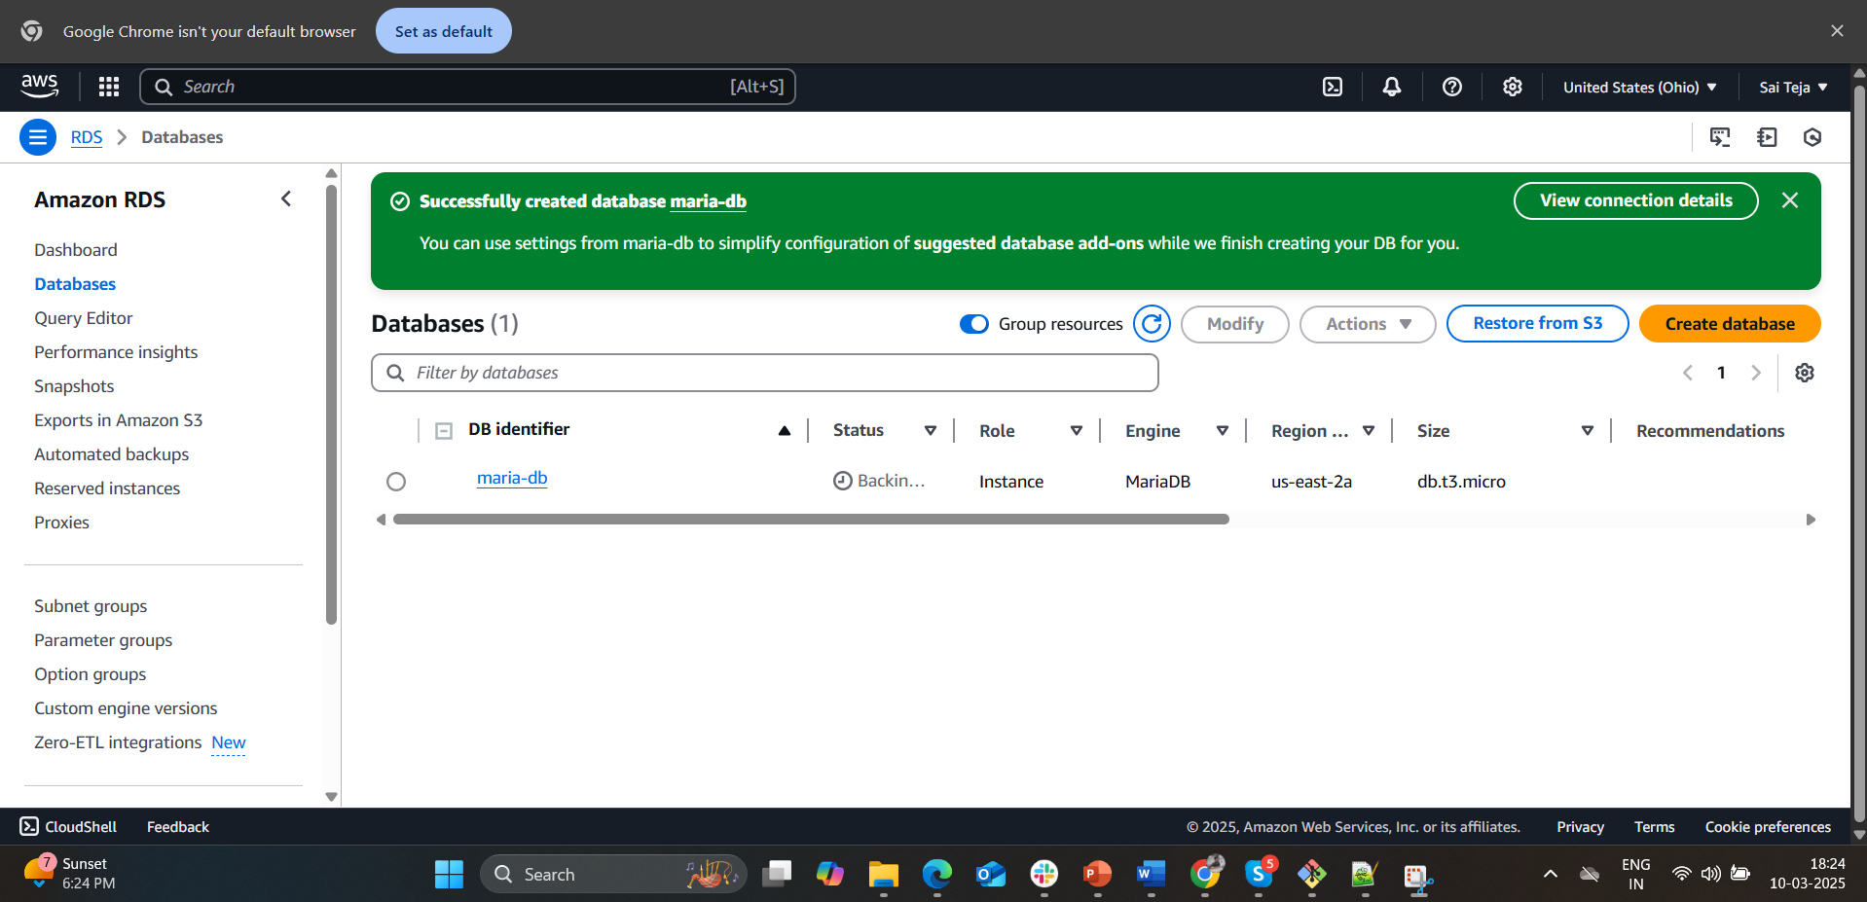

1. Migrate database from ec2 to RDS.

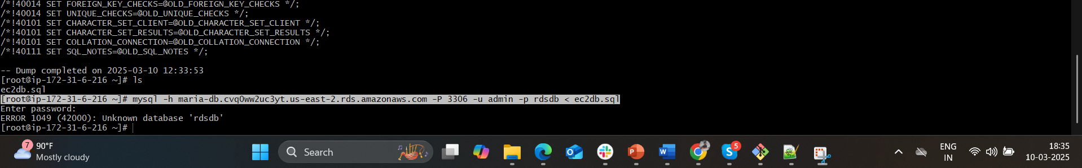

---- create one rdsdb database DDS

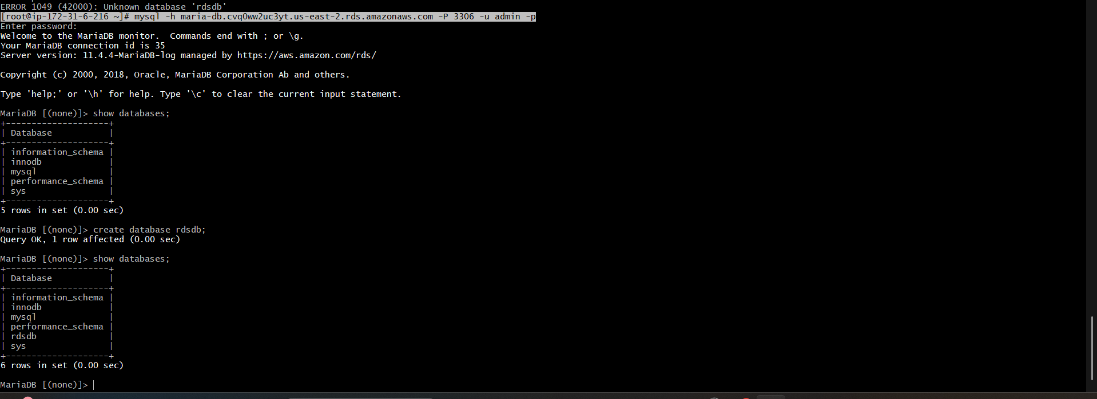



Connect to your RDS DB instance

mysql -h <replace-rds-end-point-here> -P 3306 -u rdsuser -p

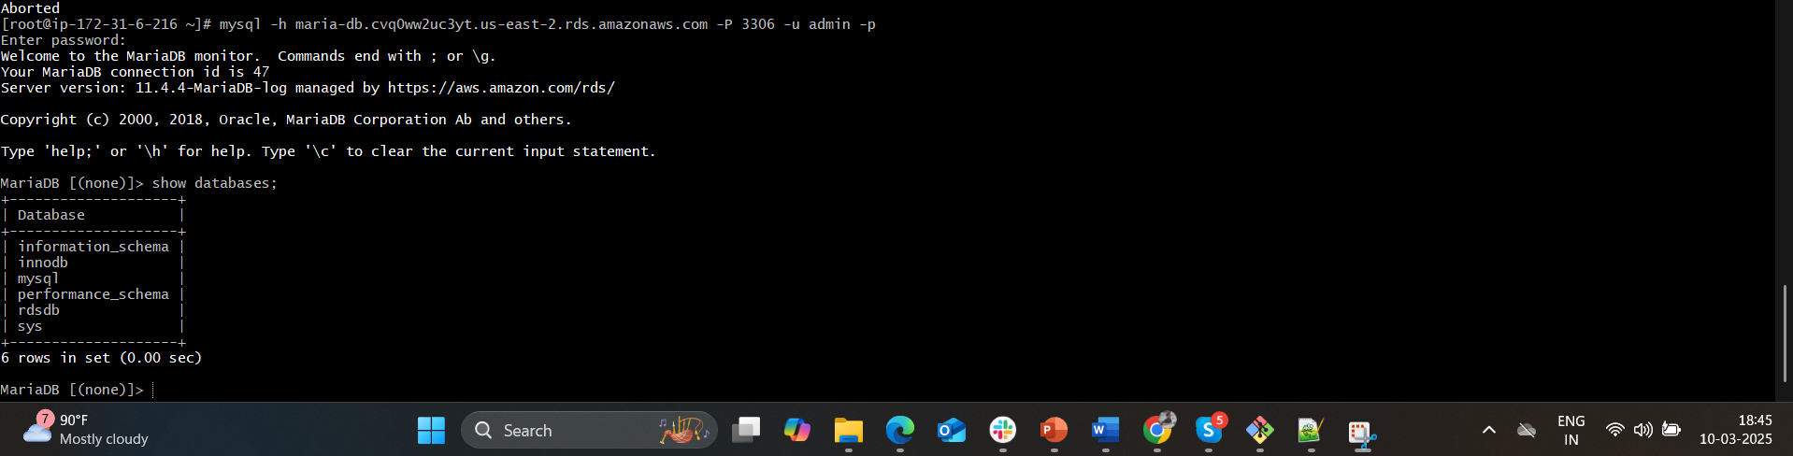

Switch to the database and verify the details.

USE rdsdb

SELECT \* FROM table1;

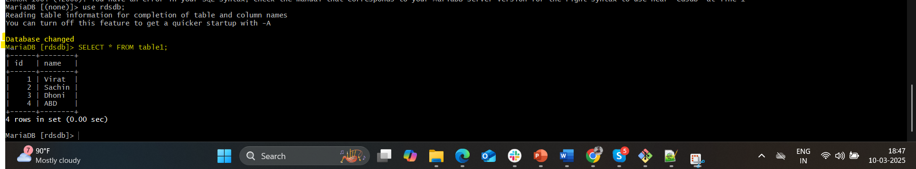

1. Install mysql db on ec2

---- install mysql using command

sudo yum install -y [https://dev.mysql.com/get/mysql57-community-release-el7-11.noarch.rpm](https://dev.mysql.com/get/mysql57-community-release-el7-11.noarch.rpm" \t "_blank)

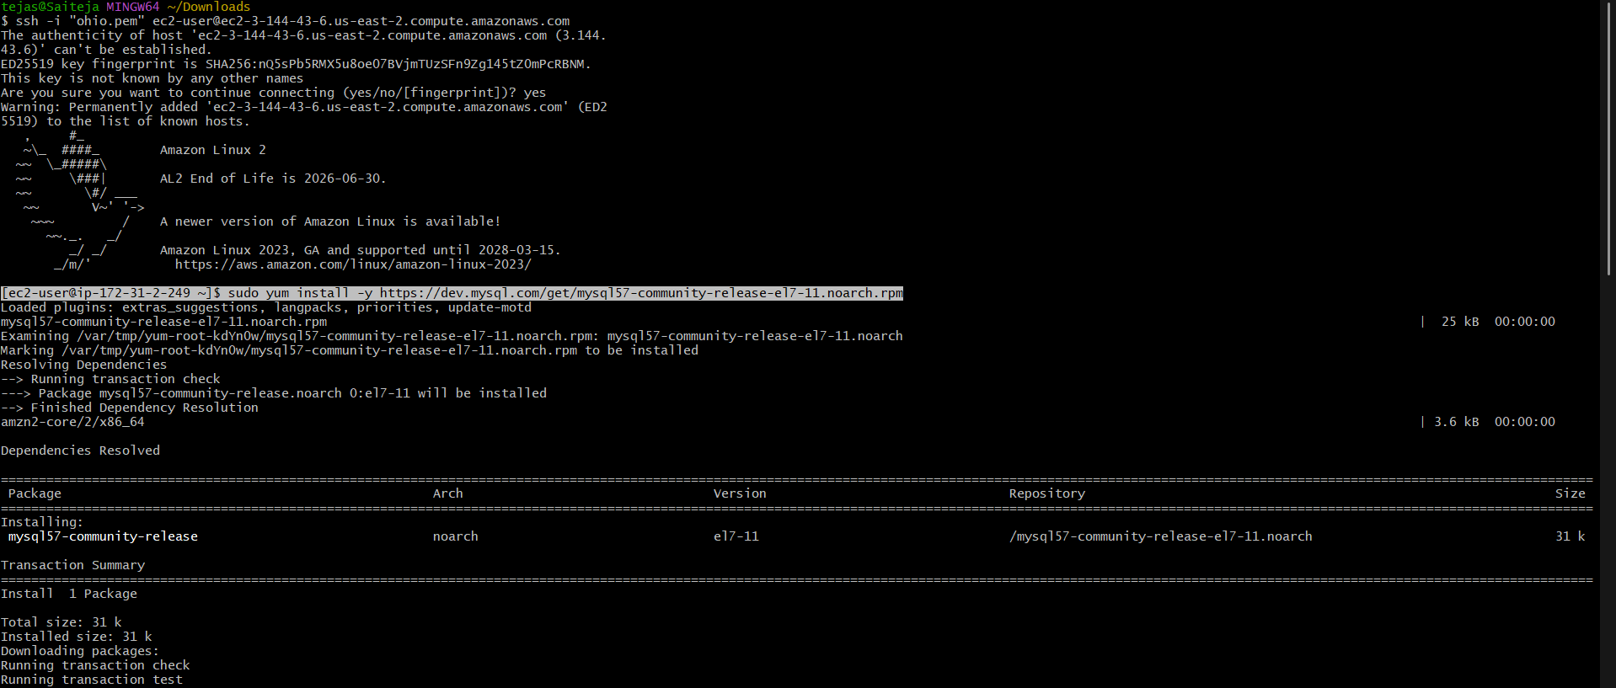

--- start mysql using commad and check the status

Systemctl start mysqld

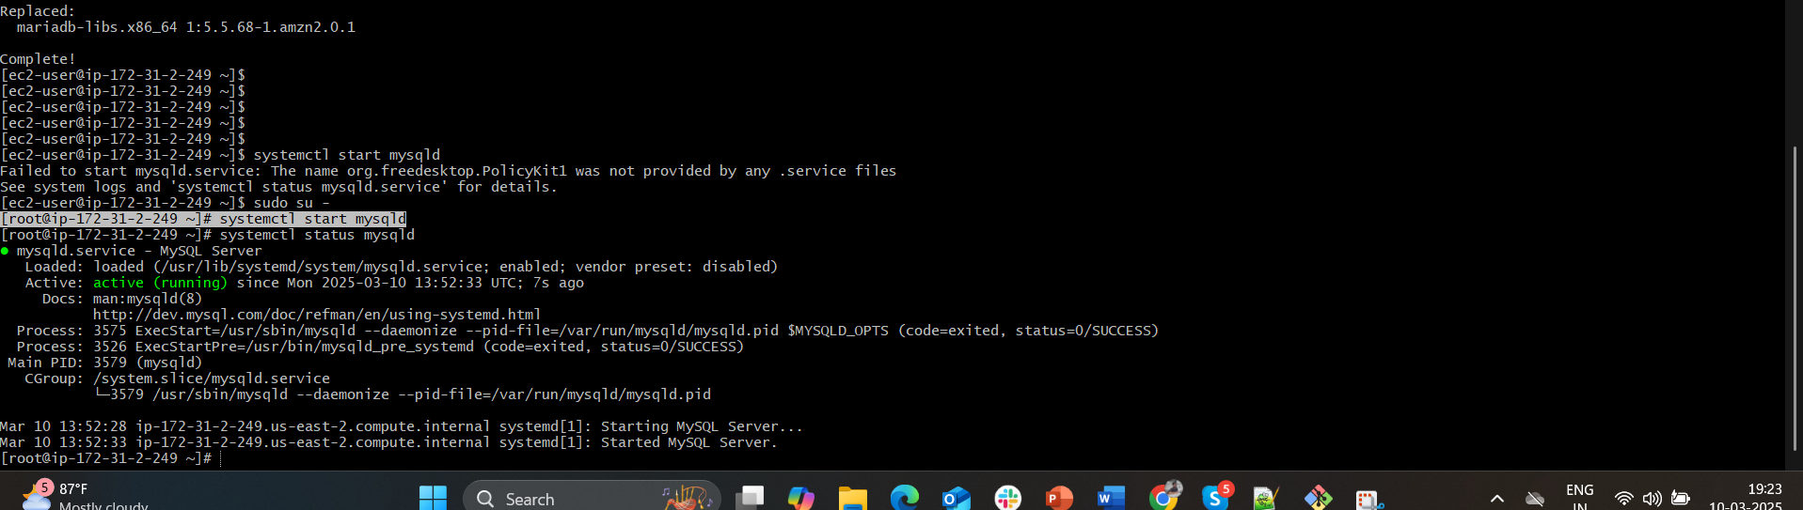

1. Launch mysql RDS imag

----- launched one RDS using mysql imag

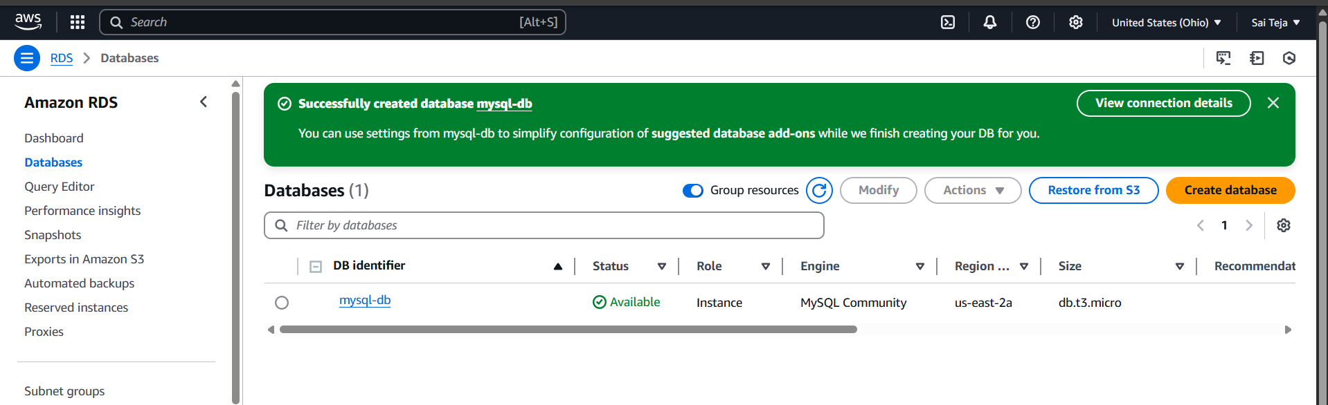

1. COnfigure multi AZ

------ go to configuration in created mysql databases

----- we can see no confifure of multi AZ

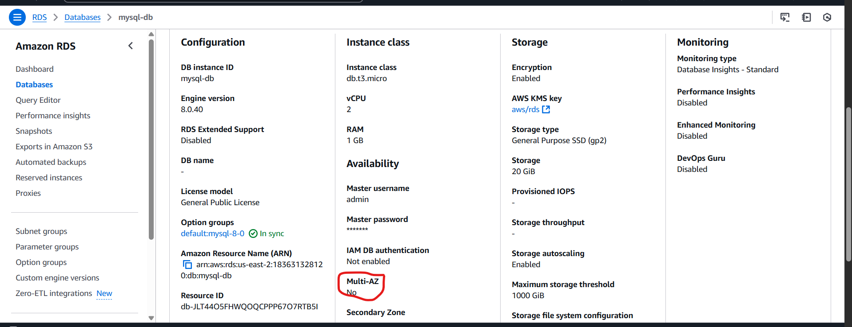

--- click on modify and go to availability & durability

--- change from Do not create a standby instance to Create a standby instance (recommended for production usage)

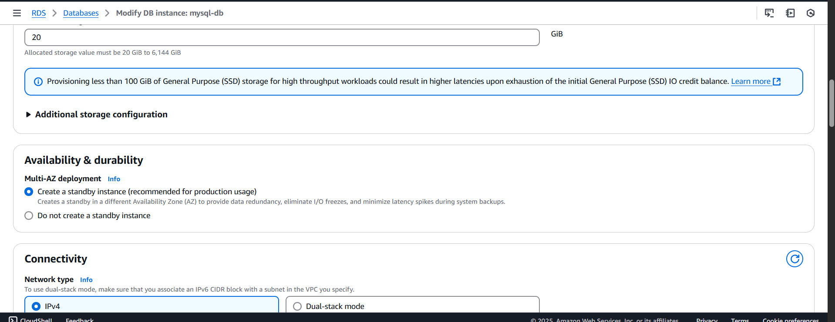

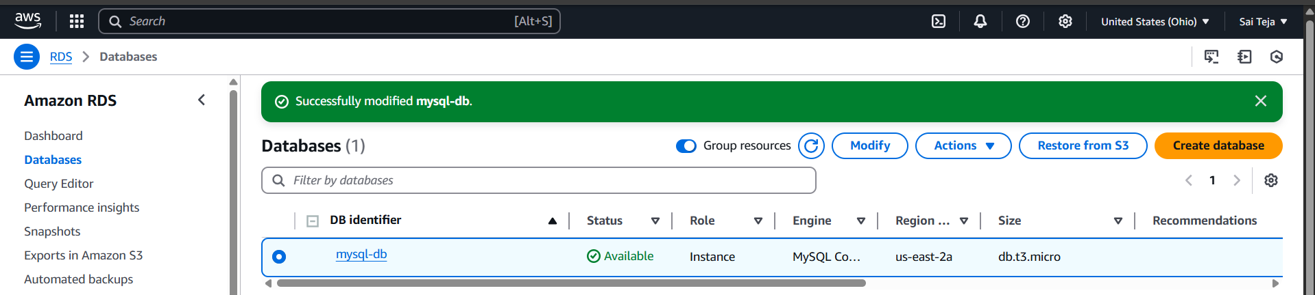

1. Take Backup of db and restore the DB

--- click on actions and select take snapshot and provide snapshot name

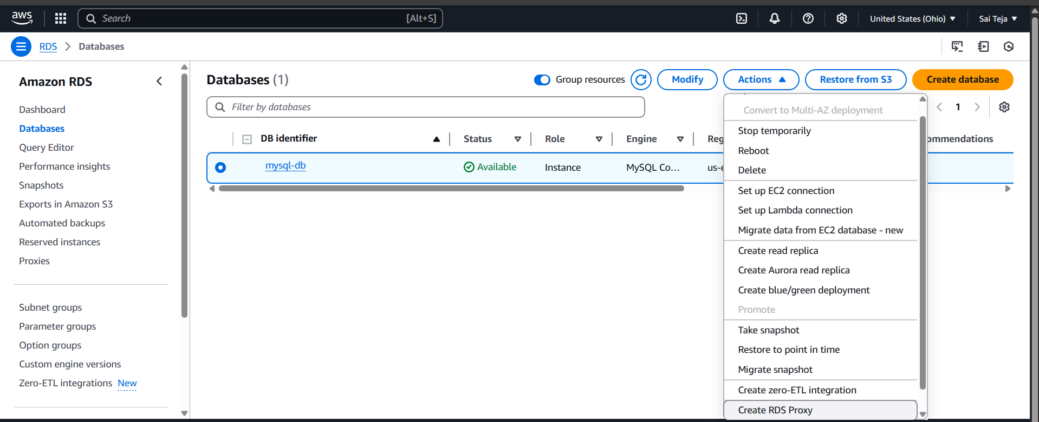

---- successfully created snapshot of mysql-db

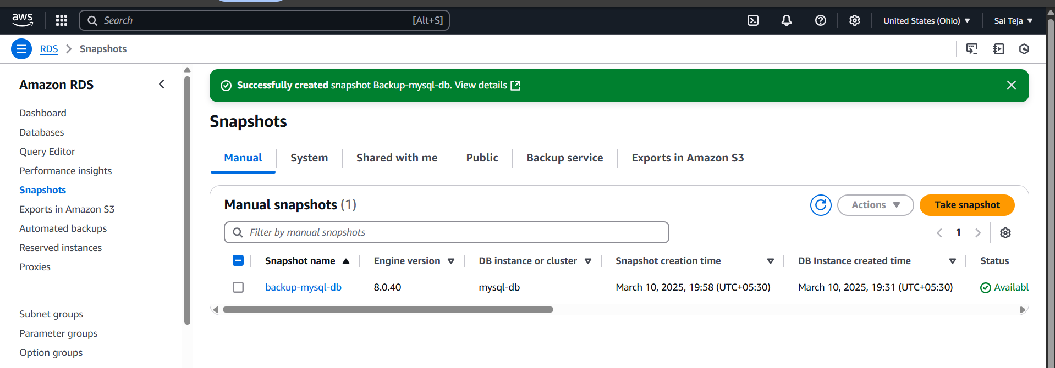

--- now delete the databases of mysql

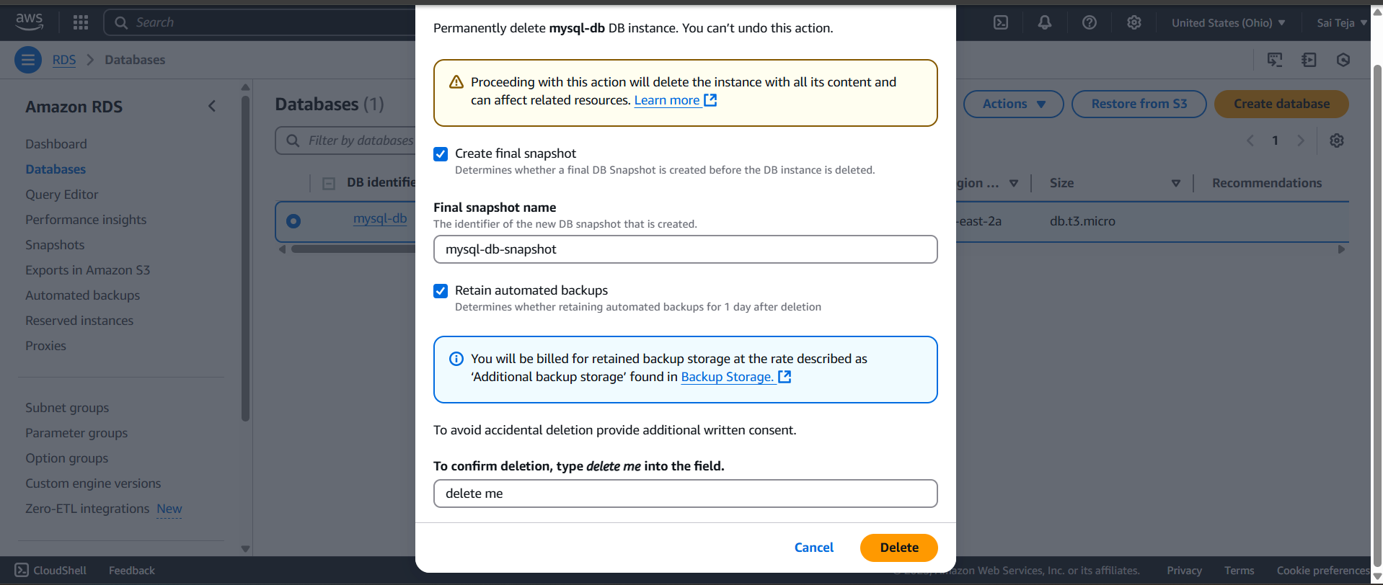

--- after deleting , go to snapshot select restore snapshot

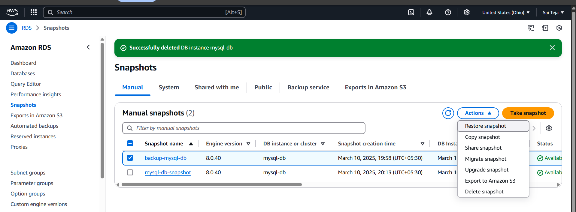

--- then we can see new database is created

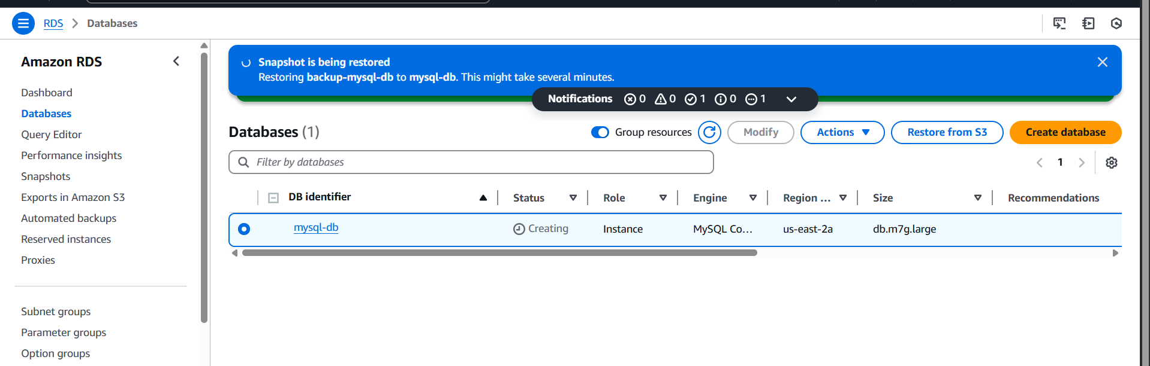

---- connect to mysql RDS and creating one database and adding content into it

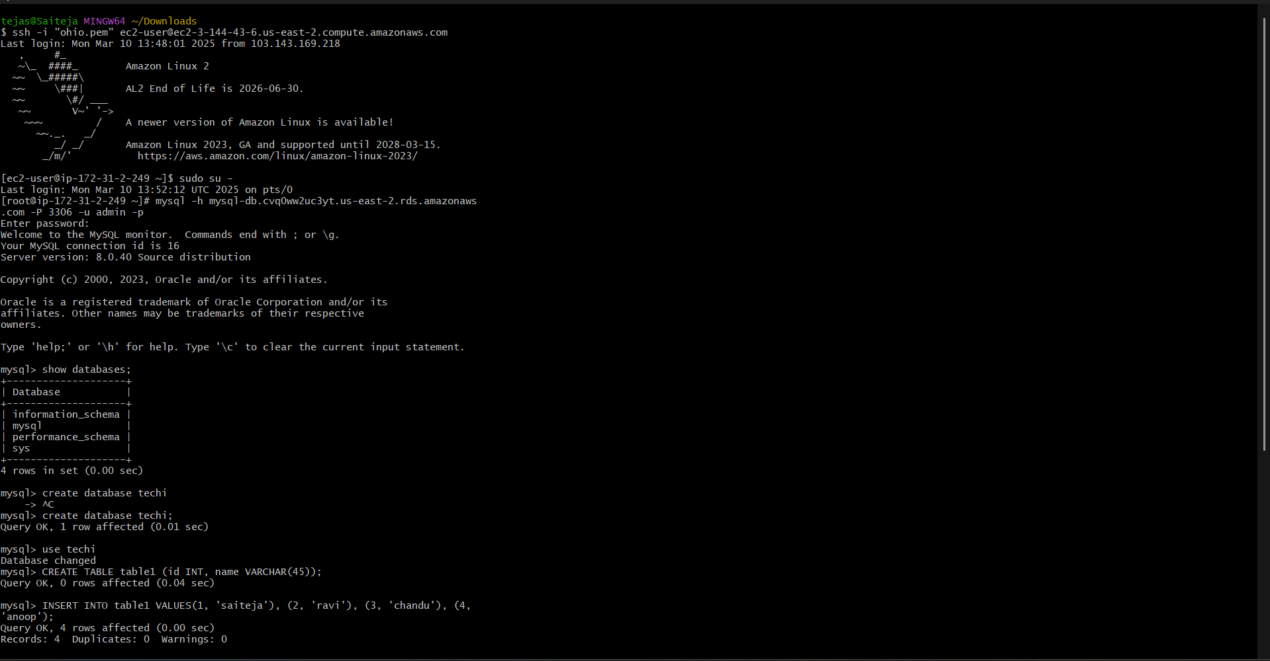

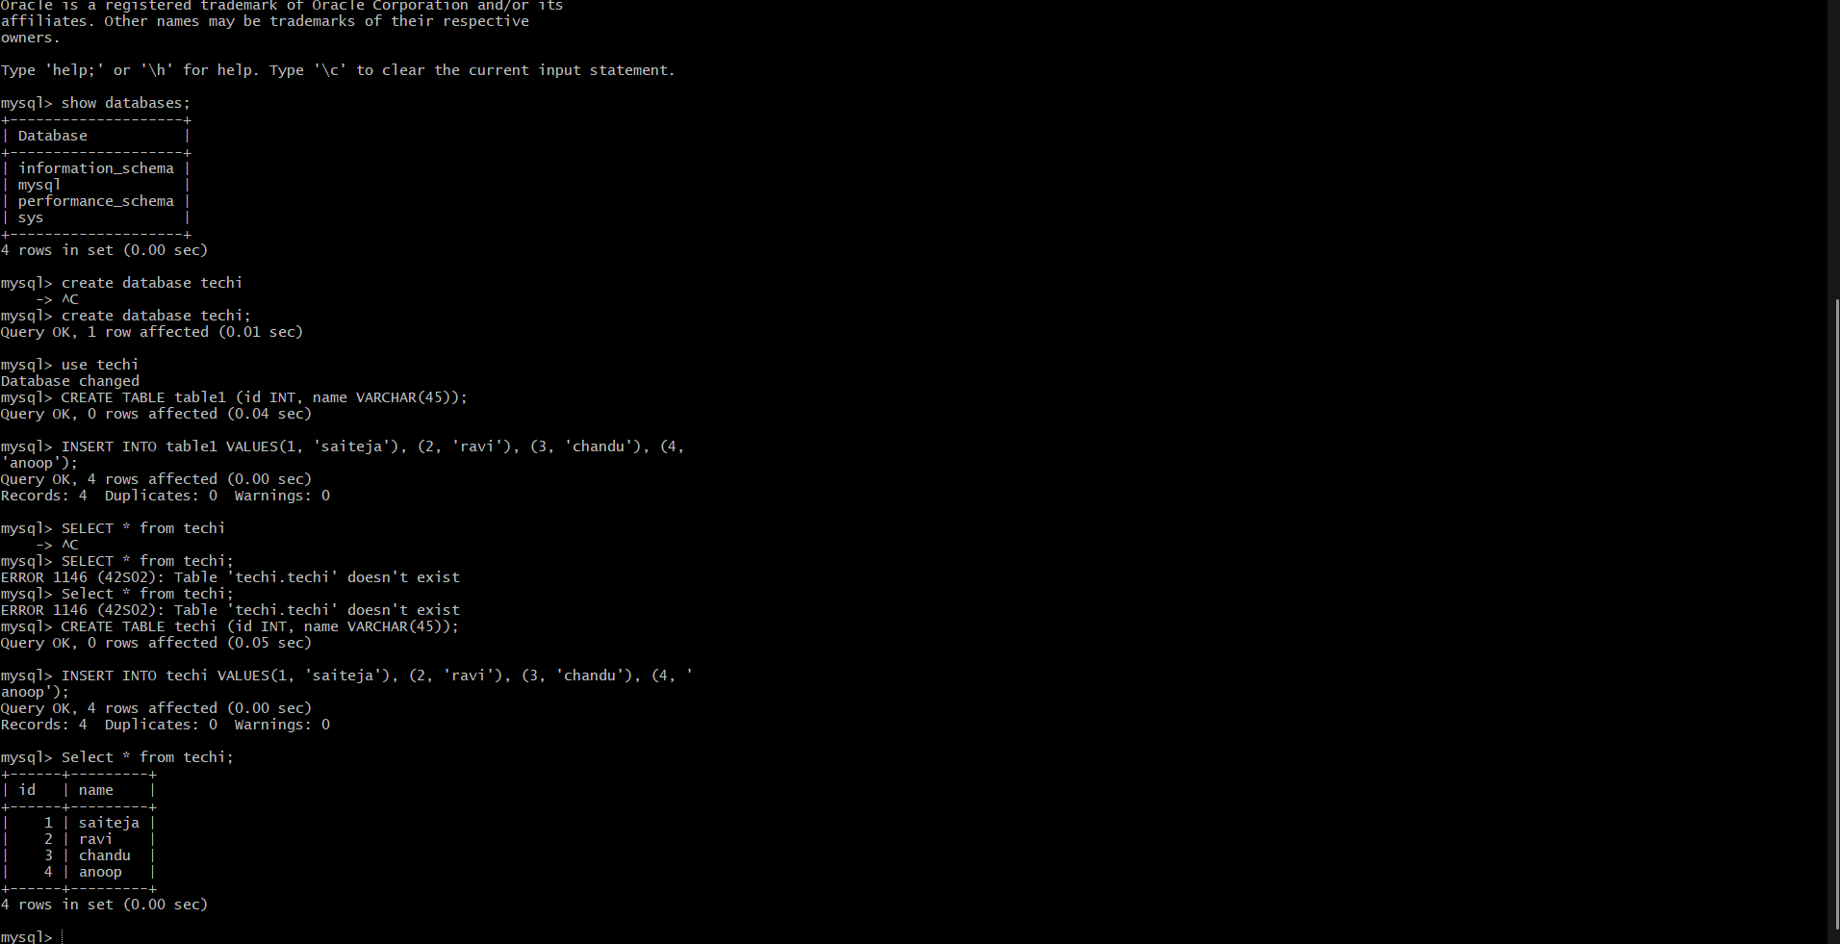

10)Create ReadReplca

---- click on actions and select create read replica

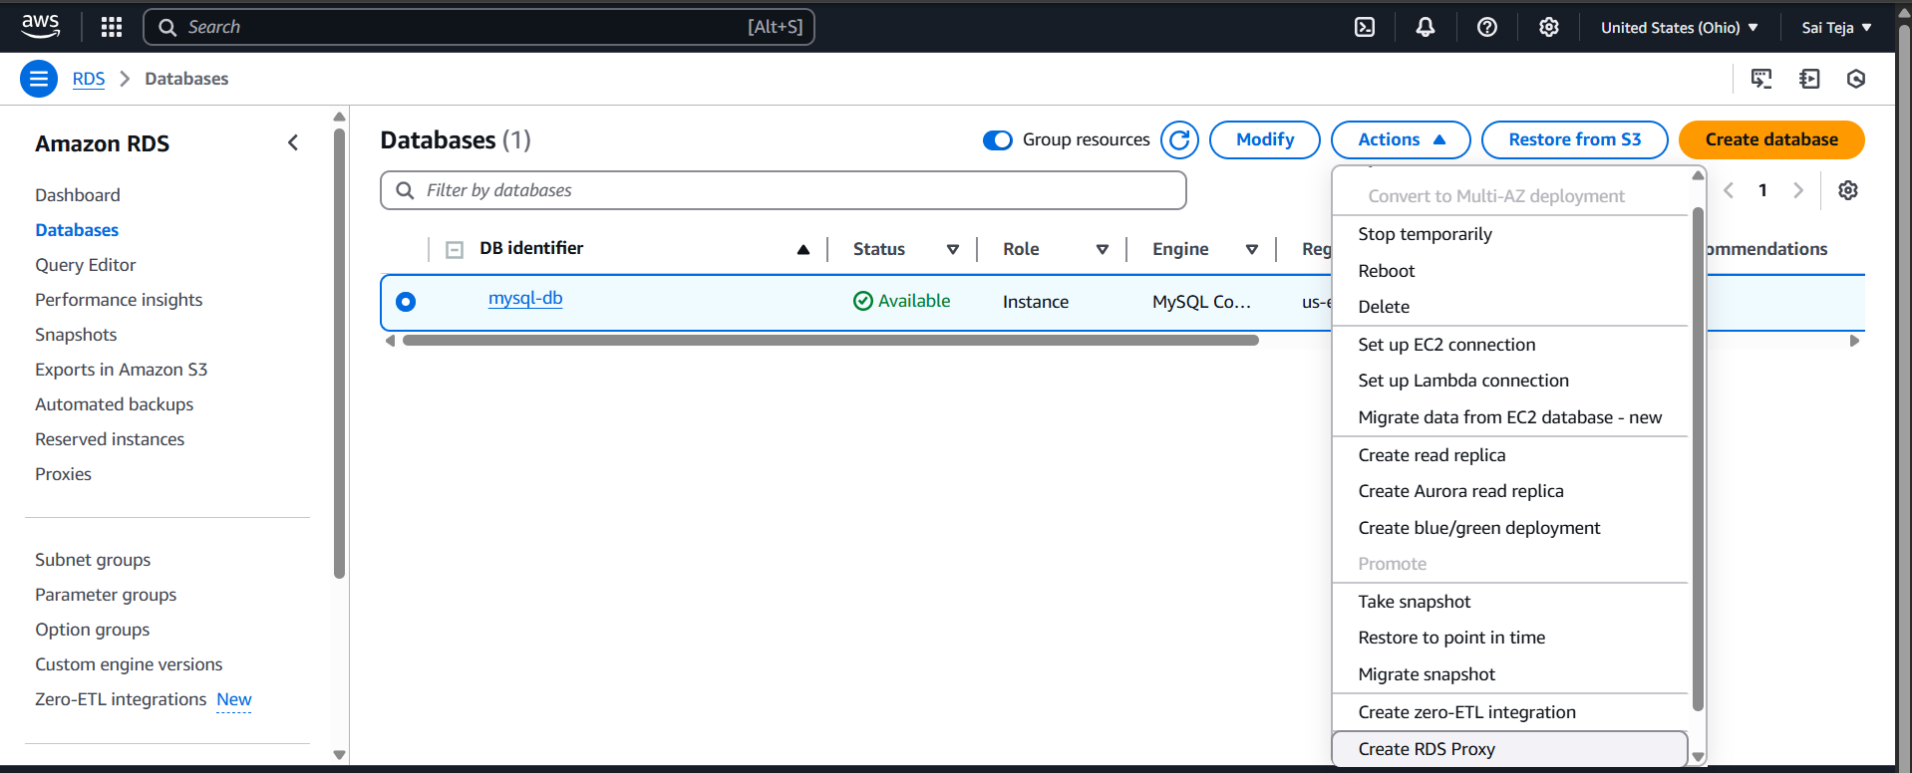

---- it will create read replica from mysql-db

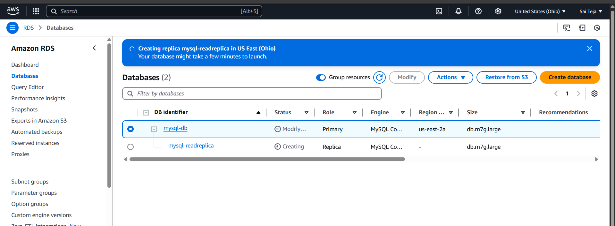

------ connect with created replica endpoint to gitbash

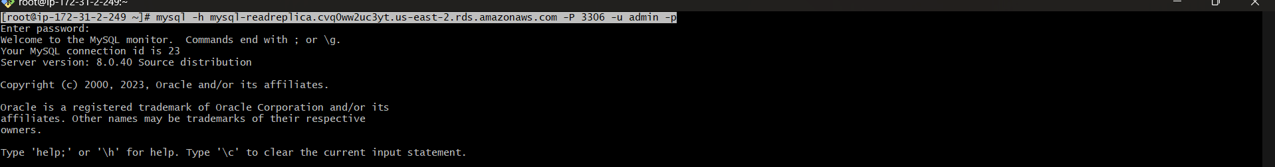

----- try to delete any table using DROP TABLE name of the table

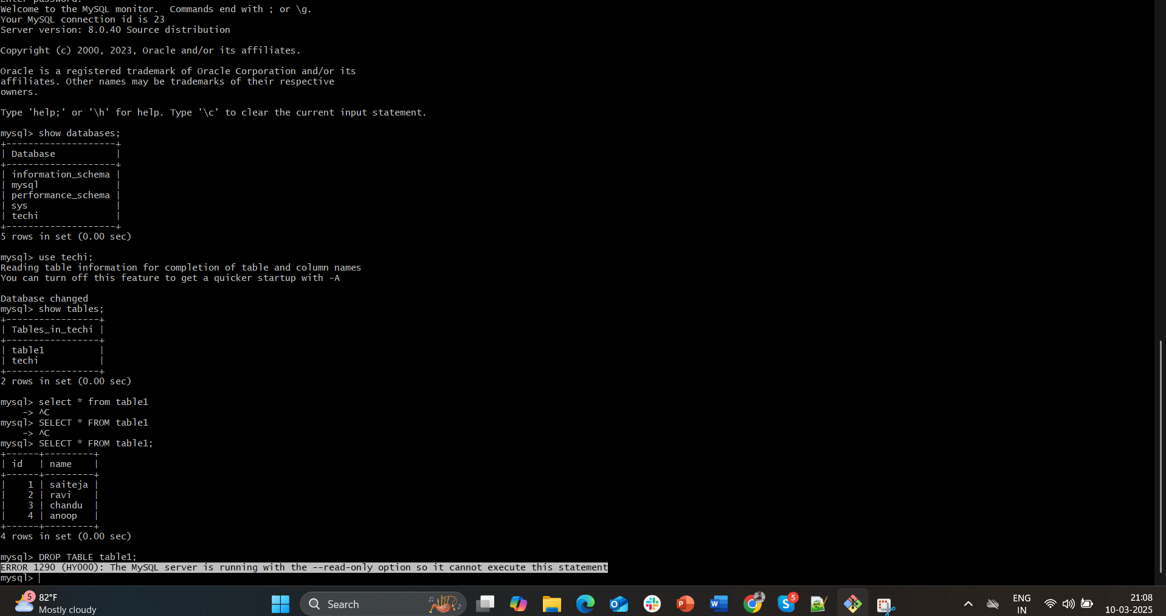

----- it shows error because we connected with read replica , so we cannot delete tables …